**Unix command to find a file in a directory and subdirectory**

Ithink I lost (or forgot the file location) a file named toms-first-birthday.mp4 on my Unix based system. Is there is a Unix bash shell command to find a file called “toms-first-birthday.mp4” in a directory and subdirectories?  
  
You need to use the find command on a Linux or Unix-like system to search through directories for files.

**Syntax**

The syntax is  
find /search/directory/ -name "matching file search criteria" -actions  
find /dir/to/search -name "pattern" -print  
find /dir/to/search -name "file-to-search" -print  
find /dir/to/search -name "file-to-search" -print [-action]

The find command will begin looking in the /dir/to/search/ and proceed to search through all accessible subdirectories. The filename is usually specified by the -nameoption. You can use other matching criteria too:

* -name file-name – Search for given file-name. You can use pattern such as *.c
* -iname file-name – Like -name, but the match is case insensitive. For example, the patterns `fo*’ and `F??’ match the file names `Foo’, `FOO’, `foo’, `fOo’, etc. The pattern `*foo*` will also match a file called ‘.foobar’.
* -user userName – The file’s owner is userName
* -group groupName – The file’s group owner is groupName
* -type N – Search by file type. N can be any one of the following:
  + b : block (buffered) special
  + c : character (unbuffered) special
  + d : directory
  + p : named pipe (FIFO)
  + f : regular file
  + l : symbolic link; this is never true if the -L option or the -follow option is in effect, unless the symbolic link is broken. If you want to search for symbolic links when -L is in effect, use -xtype.
  + s : socket
  + D : door (Solaris Unix)

The default action is to display the file name when criteria is matched. You can specify the following actions when file found:

* -print : Show pathnames of matching files.
* -exec cmd {} + : Run command cmd on a file.
* -ls : List current file in ls -dils format on screen.
* -delete : Delete file.

**Unix find command examples**

To find and report toms-first-birthday.mp4 file in your HONE directory, enter:  
$ find $HOME -name "toms-first-birthday.mp4" -print  
To find and report all mp4 files starting at the /home/vivek/ directory, enter:  
$ find /home/vivek/ -name "*.mp4" -print  
To find and report all mp4 files starting at the /home/vivek/ and /tmp/ directory, enter:  
$ find /home/vivek/ /tmp/ -name "*.mp4" -print  
For more info, see the Unix find command manual page:  
$ man find

[**A note about locate command**](https://www.cyberciti.biz/faq/howto-find-a-directory-linux-command/)**on Linux/Unix**

To find files by name use locate command:  
locate file-name  
locate pattern  
locate [option] pattern  
locate toms-first-birthday.mp4 | more  
locate -b '\toms-first-birthday.mp4'  
locate *.sh | more  
Sample outputs:

[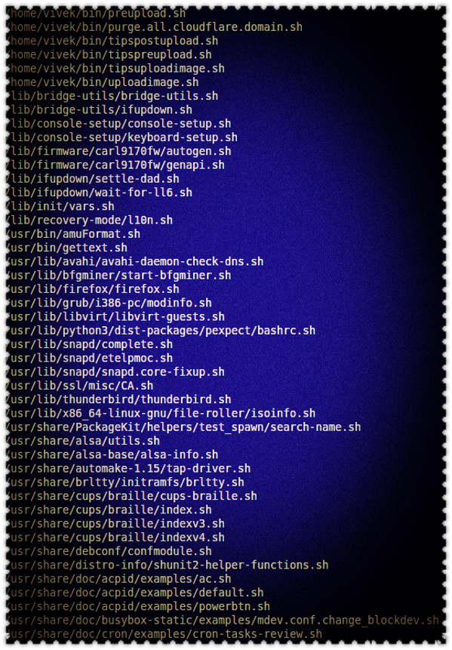](https://www.cyberciti.biz/media/new/faq/2017/12/locate-command-screenshot-on-linux-unix.jpg)locate command in action